1. Share the SQL query to remove all duplicate data from the employee table.

Query:

with cte as (

select *,

row_number() over(partition by employeeid, empname, departmentid, EmpCTC order by employeeid asc) as rn

from employee)

select employeeid, empname, departmentid, empctc

from cte

where rn = 1

Output screenshot:

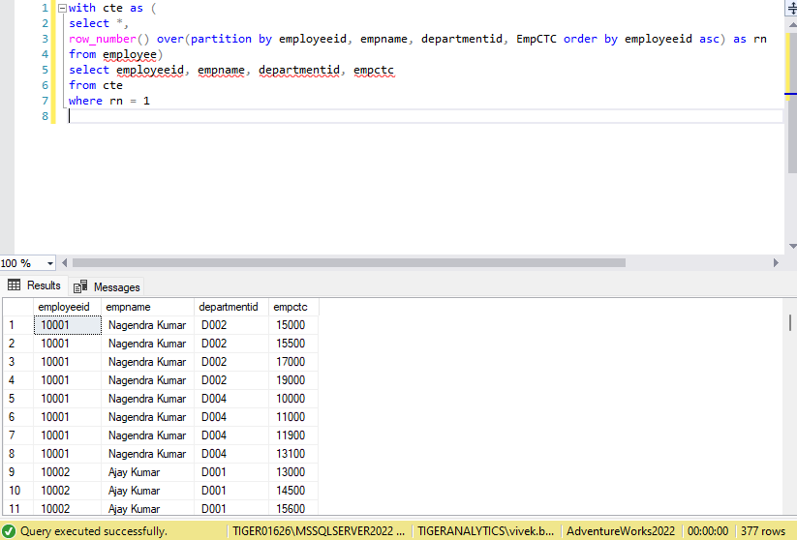

1. Share the SQL query to find the top 2nd most earning employee name from each department (department name).

Query:

with cte as (

select e.employeeid, e.empname, d.departmentid, d.departmentname, e.EmpCTC,

DENSE_RANK() over(partition by d.departmentname order by EmpCTC DESC) as rank

from employee e

join department d

on e.departmentid = d.departmentid

)

select empname, departmentname

from cte where rank = 2

Output Screenshot:

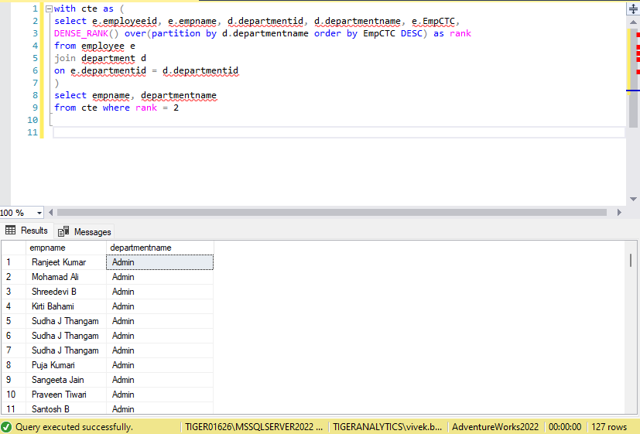

1. Share the SQL query to find the employee worked in most of departments.

Query:

with cte as ( select employeeid, empname, departmentid

from employee

group by employeeid, empname, departmentid

), cte1 as (select employeeid, empname, count(*) as count_of_departmentid,

DENSE_RANK() over(order by count(*) desc) as rank

from cte

group by employeeid, empname

)

select employeeid, empname

from cte1

where rank = 1

Output Screenshot:

